**Testing: The record of Online Tools**

**Date:** 23/4/2014

# Round 1：

## Testing Tool:

http://developers.google.com/speed/pagespeed/insights/?hl=en

## Results:

## Suggestion

**www.burgeen.com**

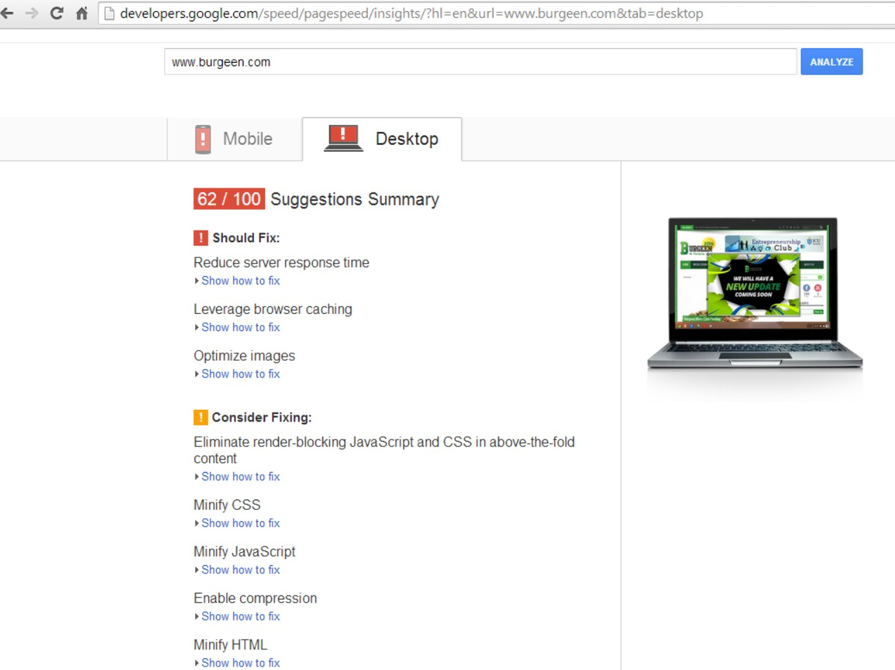

**funding.burgeen.com**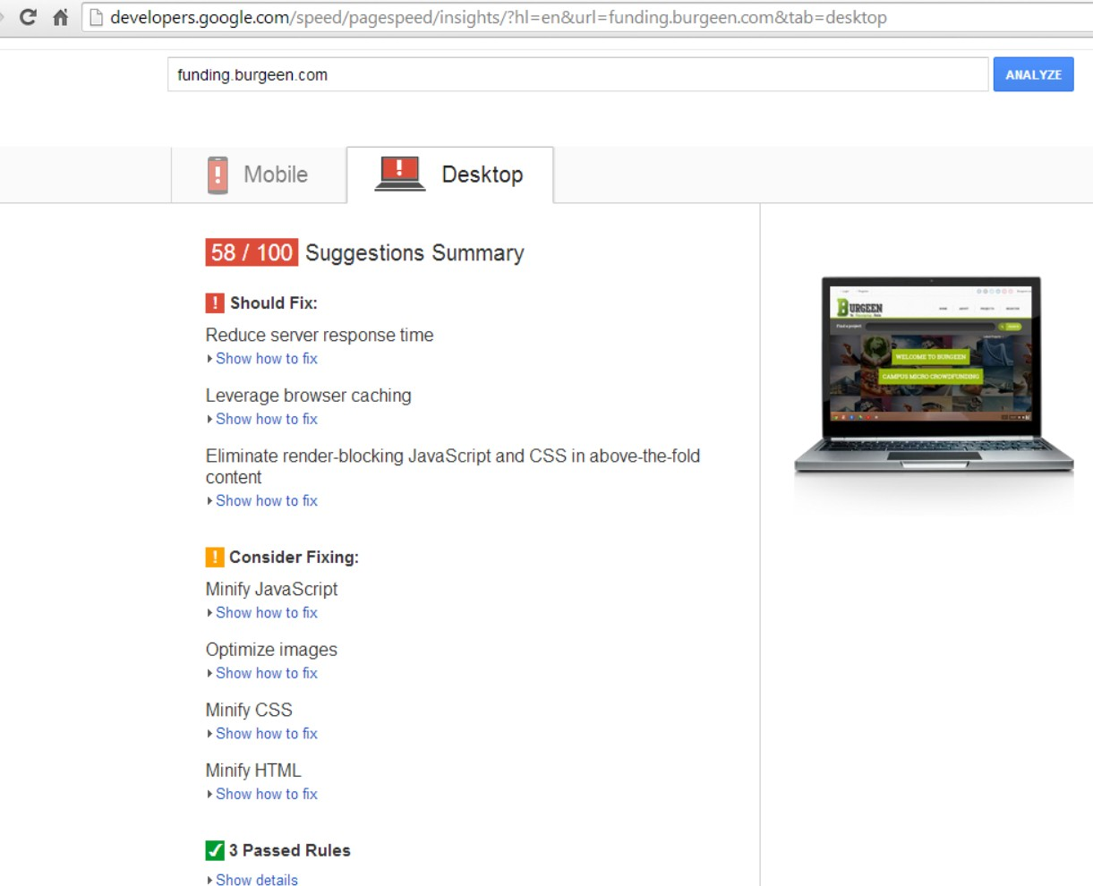

# Round 2：

## Testing Tool:

http://tools.pingdom.com/fpt/

## Results:

### 1.www.burgeen.com

#### General report:

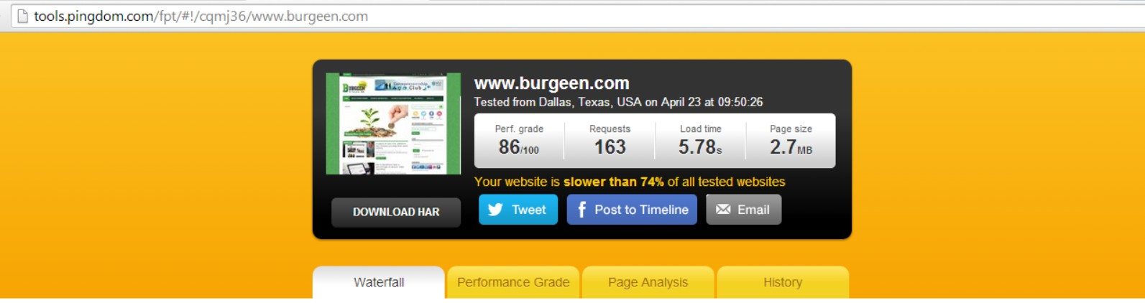

#### Performance grade:

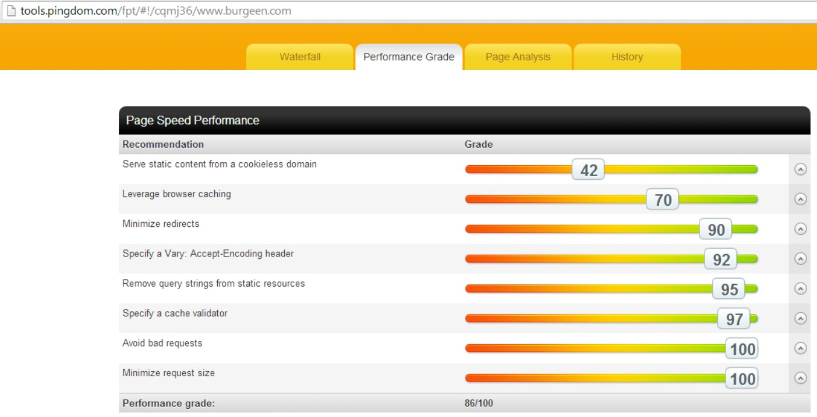

#### Page Analysis：

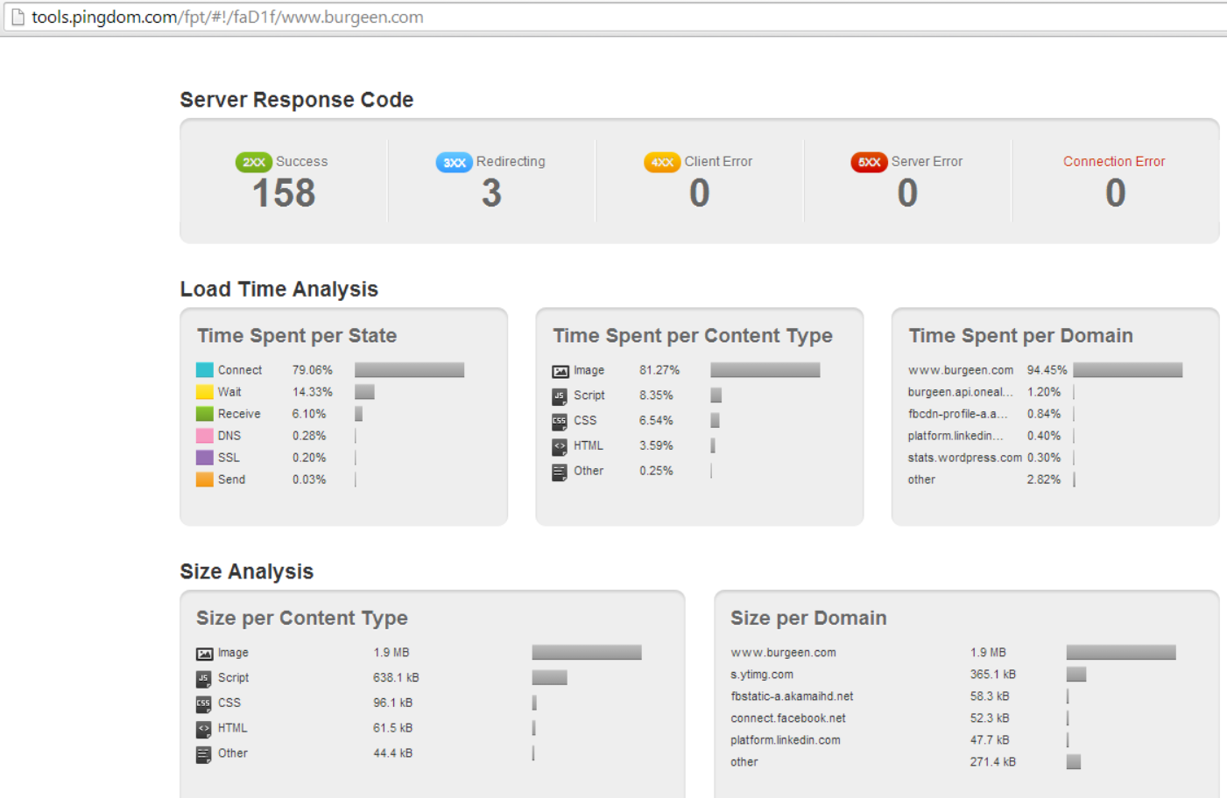

### 2. Funding.burgeen.com

#### General report:

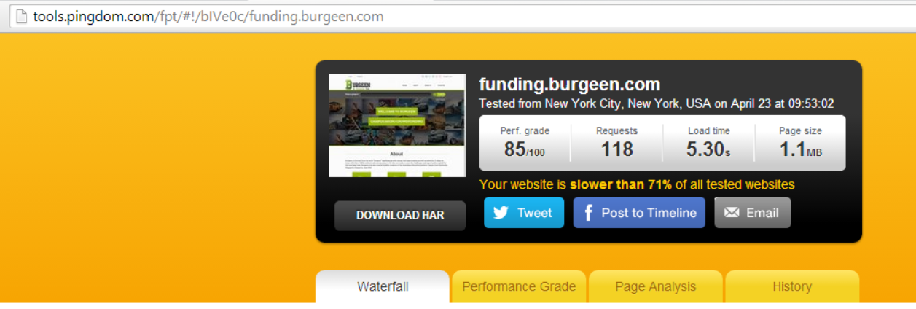

#### Performance grade:

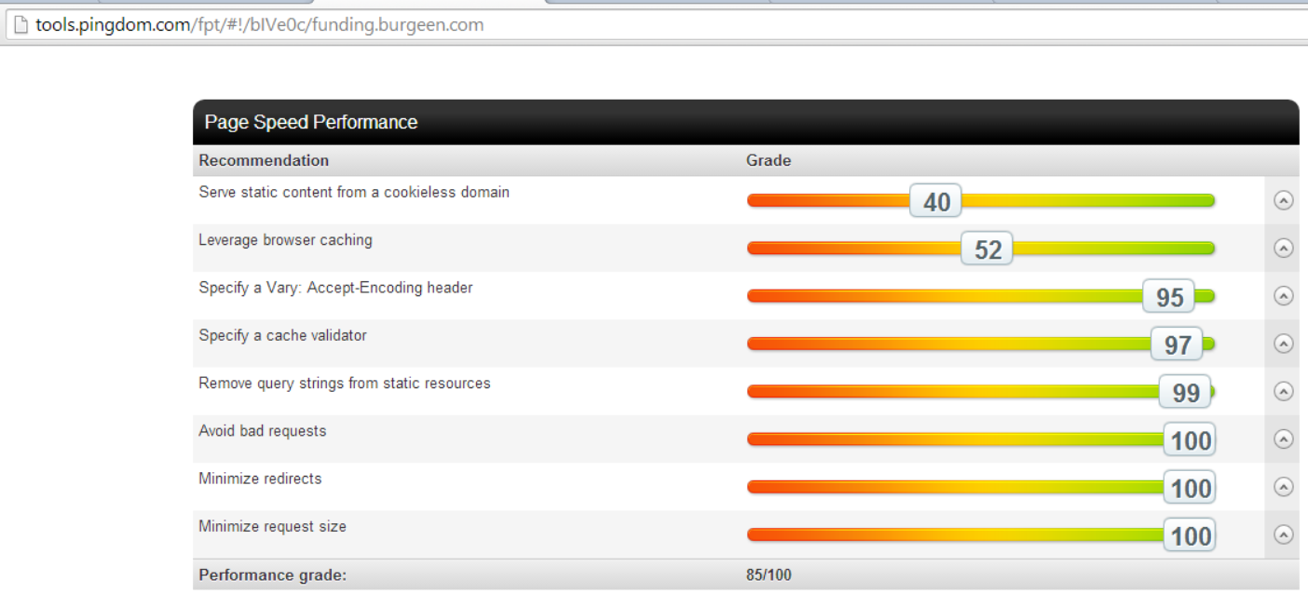

#### Page Analysis：

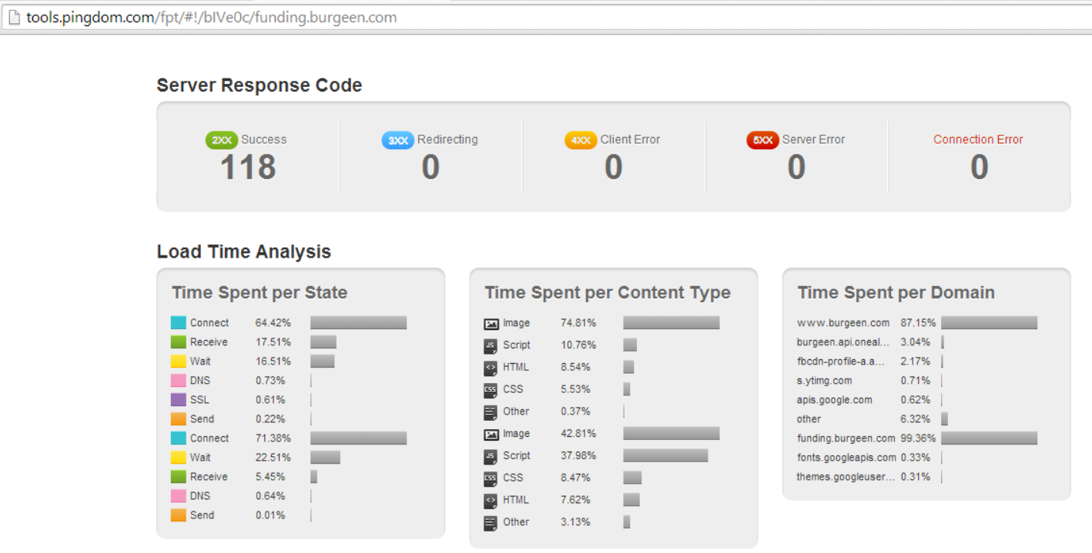

# Round 3：

## Testing Tool:

## <http://www.neustar.biz/resources/tools/free-website-performance-test#.U1ciavmSyaQ>

## Results:

www.burgeen.com

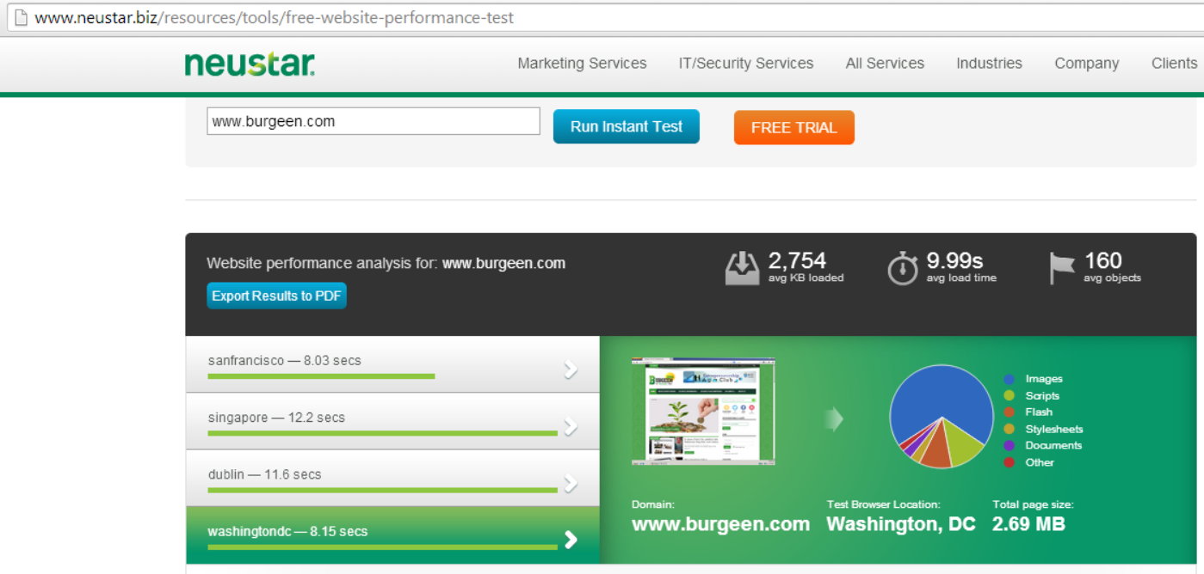

funding.burgeen.com

